**ULTRASONIC SENSOR**

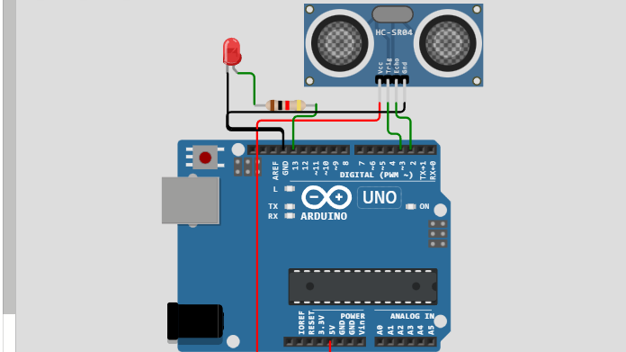

const int TRIG_PIN = 7;

const int ECHO_PIN = 8;

const unsigned int MAX_DIST = 23200;

void setup() {

pinmode(TRIG_PIN, OUTPUT);

digitalWrite(TRIG_PIN, low);

pinMode(ECHO_PIN, INPUT);

Serial.begin(9600);

}

Void loop() {

Unsigned long t1;

Unsigned long t2;

Unsigned long pulse_width;

float cm;

float inches;

digitalWrite(TRIG_PIN, HIGH);

digitalMicriseconds(10);

digitalWrite(TRIG_PIN, LOW);

while ( digitalRead(ECHO_PIN) == 0 );

t1 = micros();

  while ( digitalRead(ECHO_PIN) == 1);

  t2 = micros();

  pulse_width = t2 - t1;

cm = pulse_width / 58.0;

  inches = pulse_width / 148.0;

if ( pulse_width> MAX_DIST ) {

**Serial**.println("Out of range");

  } else {

**Serial**.print(cm);

**Serial**.print(" cm \t");

**Serial**.print(inches);

**Serial**.println(" in");

  }

delay(60);

}